Course Number: 420-P55-AS

Course Title: Internet Programming I

Session: Autumn 2017

**final project**

**TITLE: WIne Club**

**Due DATE: 04/12/2017**

**submitted**

**to**

**TEACHER: Quang Hoang Cao**

**By**

**Livia Ferraz Ximenes**

**1530081**

**table of contents**

Contents

1) Project description 2

2) TECHNOLOGIES USED 3

3) Project development 3

Phase I Analysis and design 3

Phase II Implementation 6

Phase III Testing the program 11

4) Conclusion 11

# Project description

The purpose of this project is to execute a complete design and development of a professional wine delivery website for Wine Club company. The goal of this project is to show what Wine Club does, how it works and in which cities it operates in. Then, make people sign up on a subscription plan. The web site will be used by people interested in getting to know different kinds of wine from different places in the world. They will be able to order online wine that will be delivered at their houses.

It will be a one-page website containing information provided by Wine Club, with simple navigation. The site should be responsive and easy to navigate to enable even basic computer users to subscribe. The design should be hi-end, pleasant and clean.

# TECHNOLOGIES USED

The website will be developed in Brackets and the major web technologies used will be HTML5, CSS3, JavaScript and JQuery.

# Project development

## Phase I Analysis and design

The basic function of the web site will be to provide the users three types of wine subscriptions. The web site will be composed of eight parts:

1. Header: will comprise a big picture, a logo and an impact phrase to motivate users to subscribe
2. Features: small description of the benefits of subscribing to the website
3. Images
4. How it works: instructions on how to order
5. Cities: addresses of the cities the company provides service
6. Testimonials: customer testimonials
7. Plans: Subscription plans
8. Contact us form

Section 1: Header

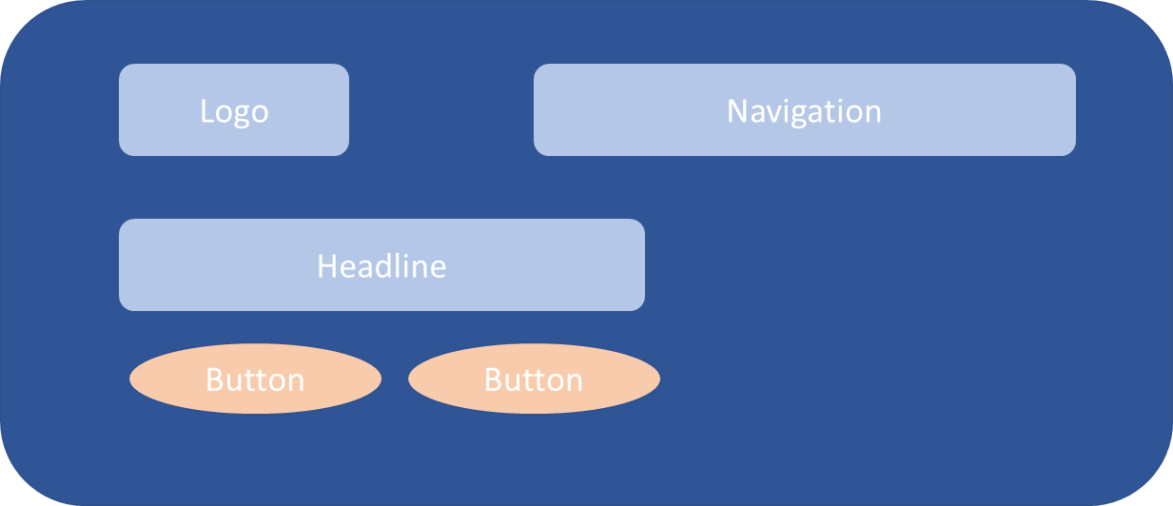

Section 2: Features

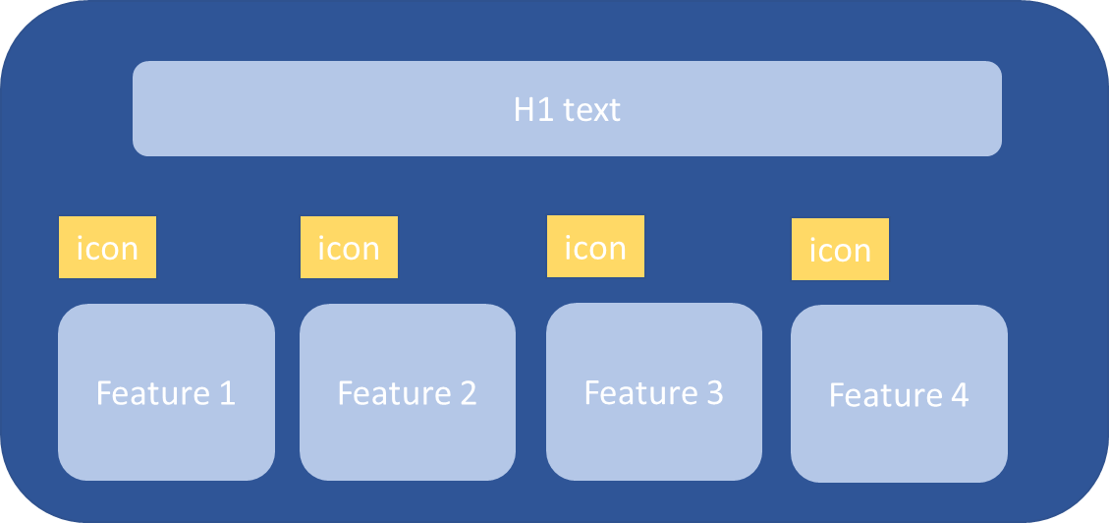

Section 3: Images

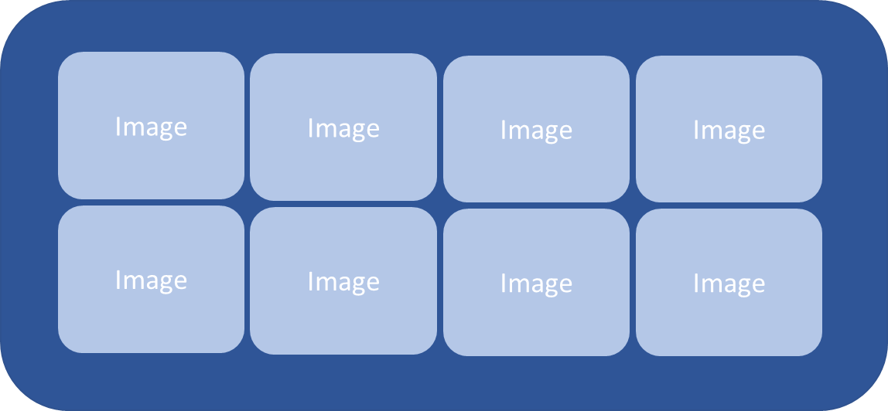

Section 4: How it works

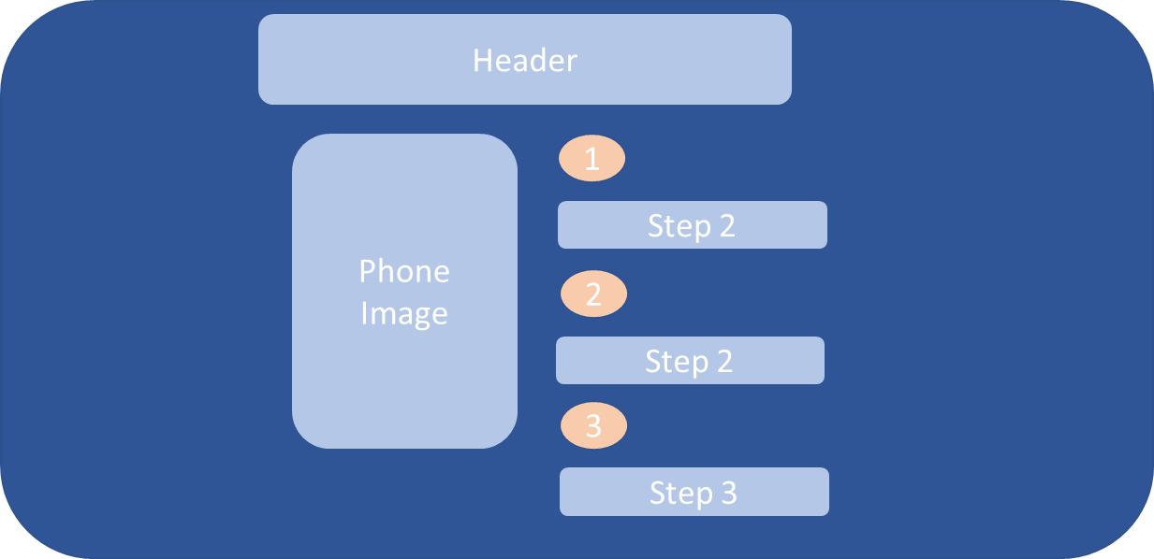

Section 5: Cities

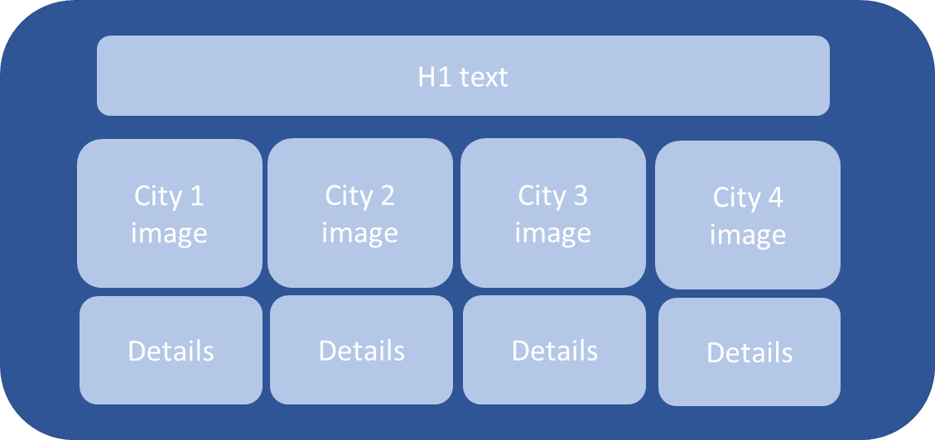

Section 6: Testimonials

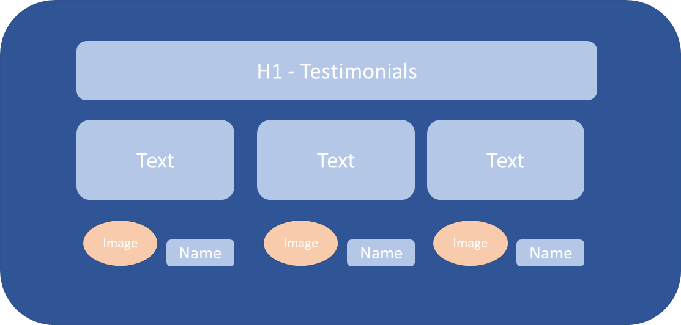

Section 7: Plans

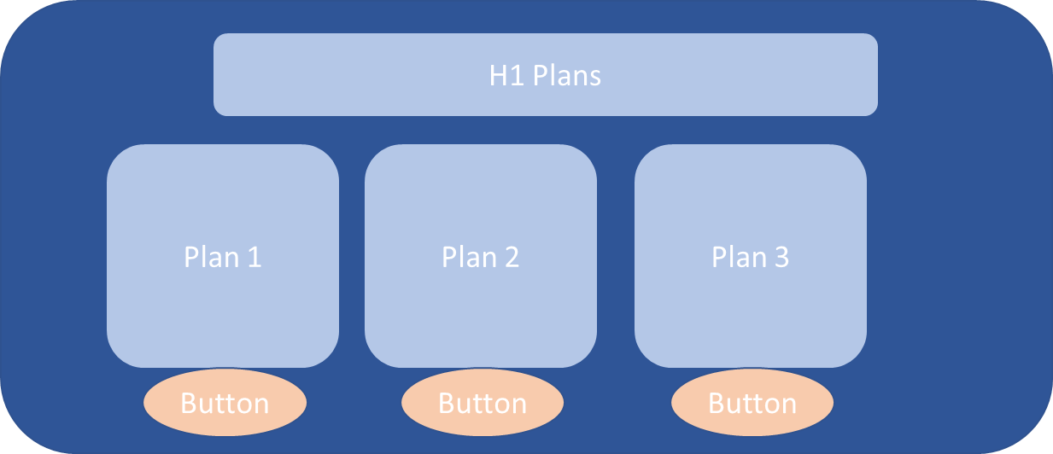

Section 8: Contact us

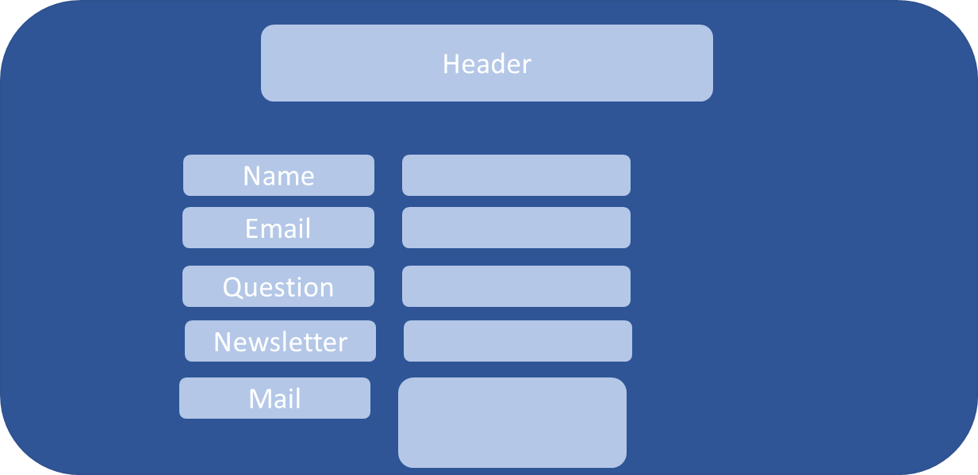

Section 9: Footer

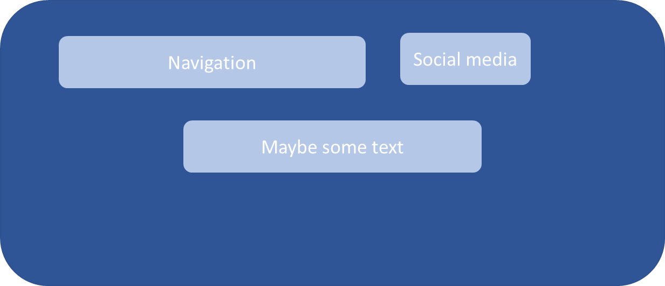

## Phase II Implementation

The first part of the website contains a logo, a navigation bar with four links to click, a background picture, an impact sentence and two buttons.

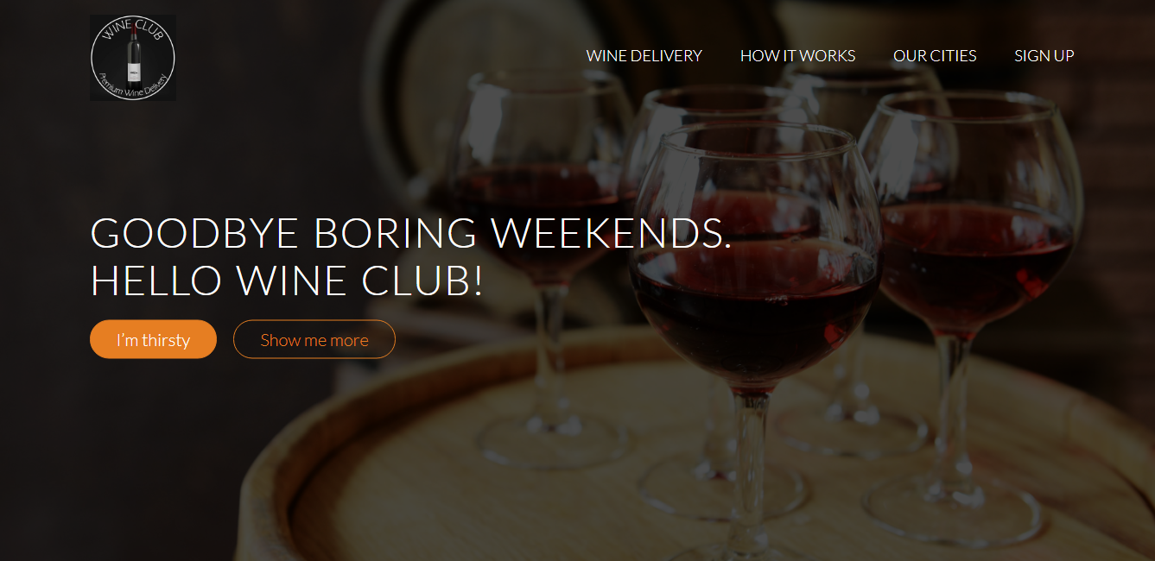

There are some effects done with CSS that appear when the mouse hover over the buttons or the navigation bar links.

Effect for buttons:

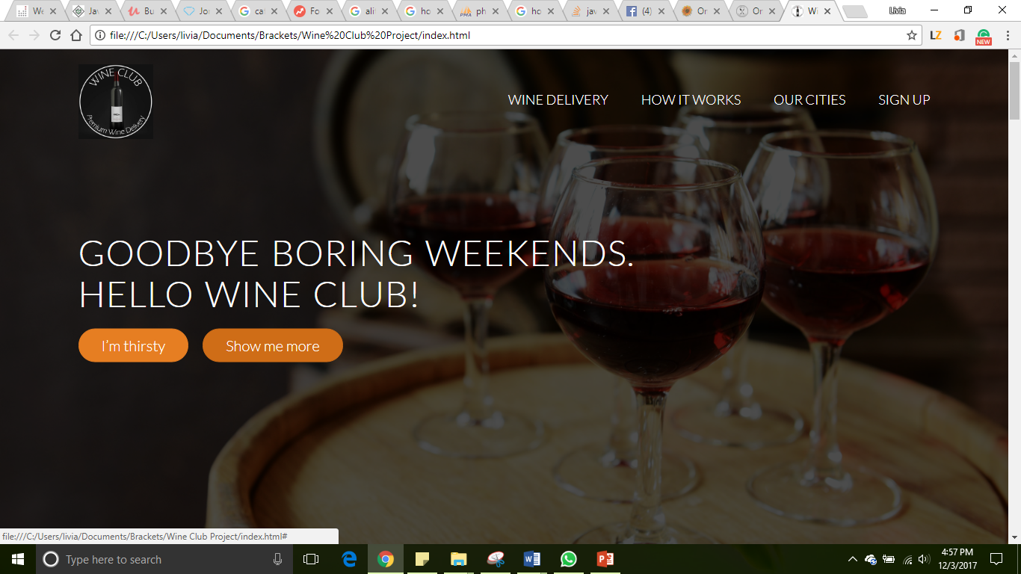

Effect for navigation bar:

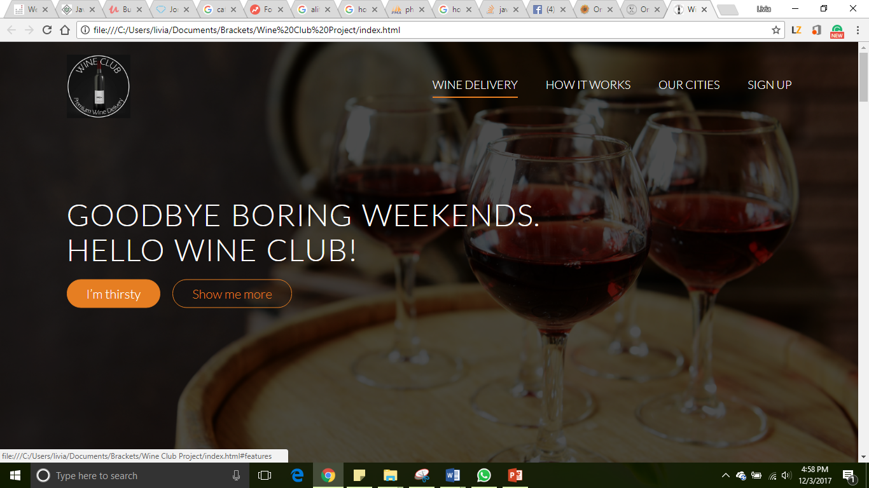

Once the screen gets smaller (mobile size), the navigation bar disappears,

and the user can click over the three lines on the right top to display it. This was done using jQuery.

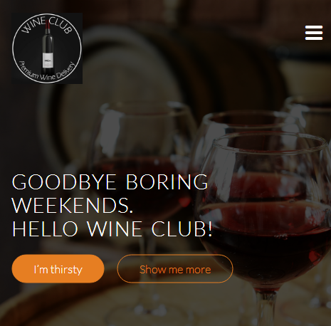

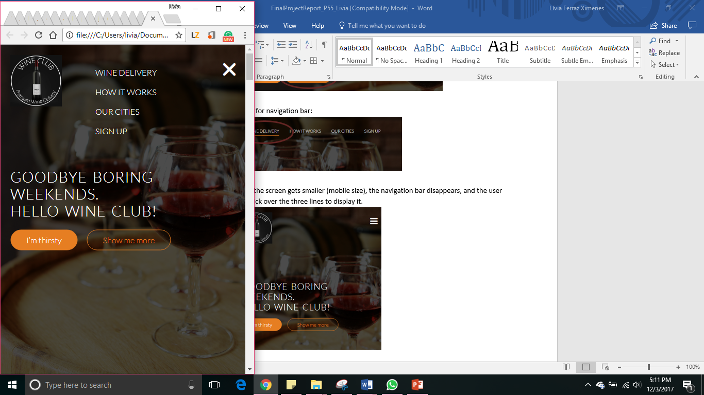

Once the user starts scrolling down, the navigation bar appears on the top of the screen. This enables the user keep seeing the logo and the four most important features of the web site.

In the second section, the four features appear 0.5 seconds after the user scrolls down to this section.

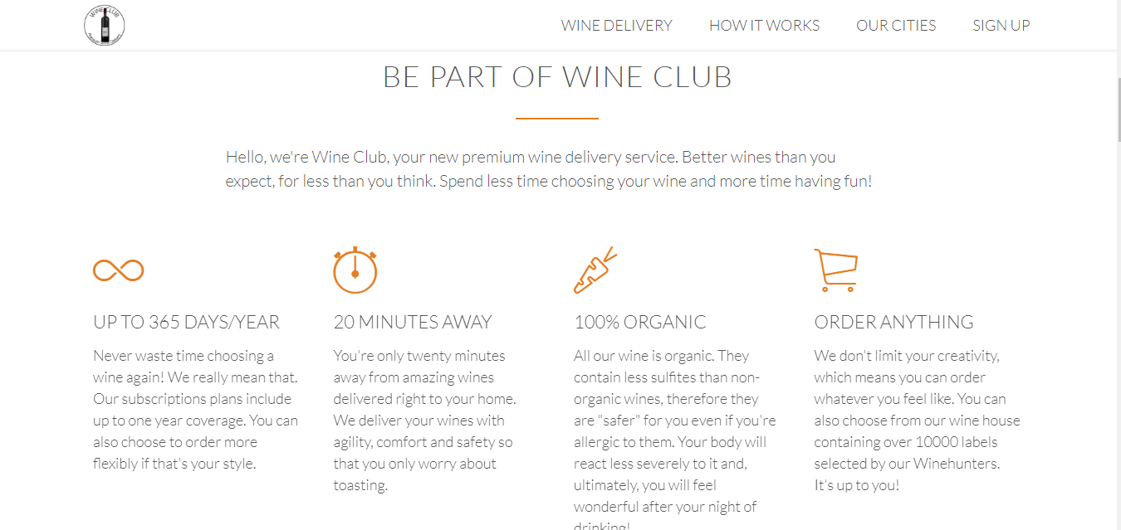

In the images section, an animation was included to brighten and approximate the image when the user hovers the mouse over the image.

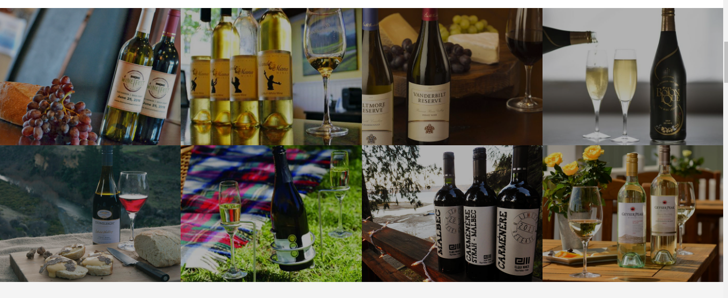

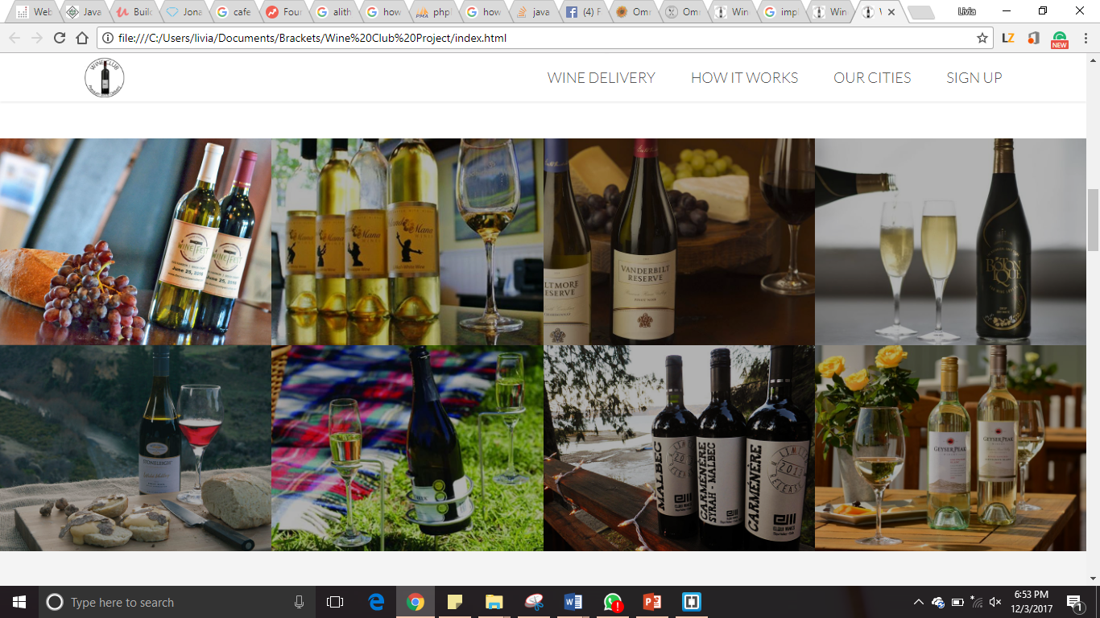

In the “How it works” section an animation was made in the iPhone image (fadeInUp effect). This effect makes the image appear in the bottom of the screen and move up slowly to its place.

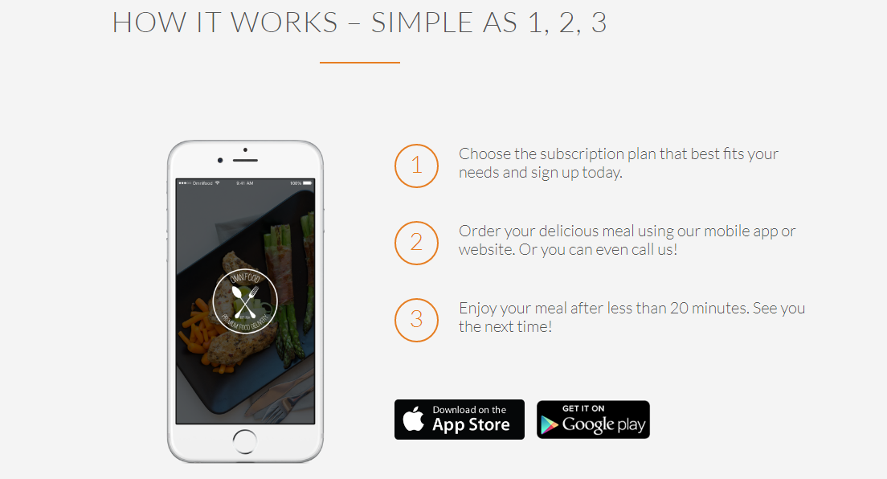

In the Cities section, the cities’ images and text also appear slowly to the user when he/she scrolls down.

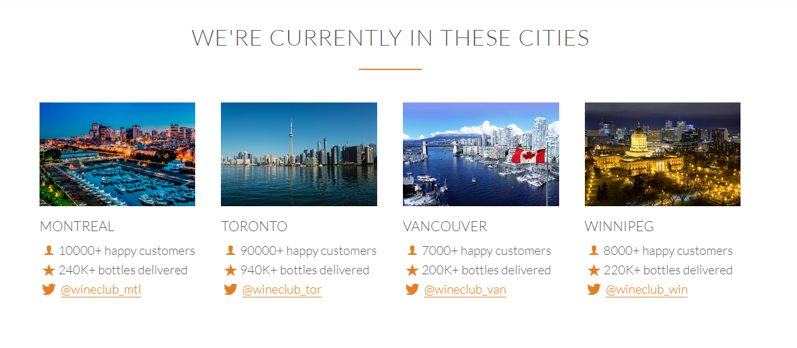

In the Testimonials section, the background image stands still when the user scrolls up and down using the background-attachment method in CSS.

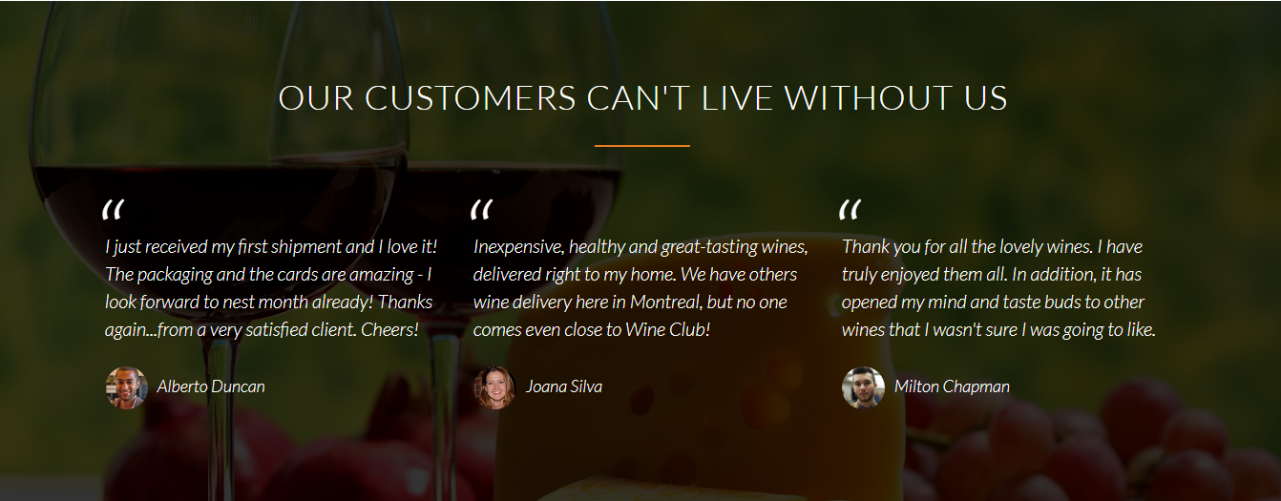

In the “Subscription plans” section the *animated pulse* jQuery class was added to the premium plan, so it pulses when the user scrolls down and makes him pay more attention to the most expensive (and most profitable) plan.

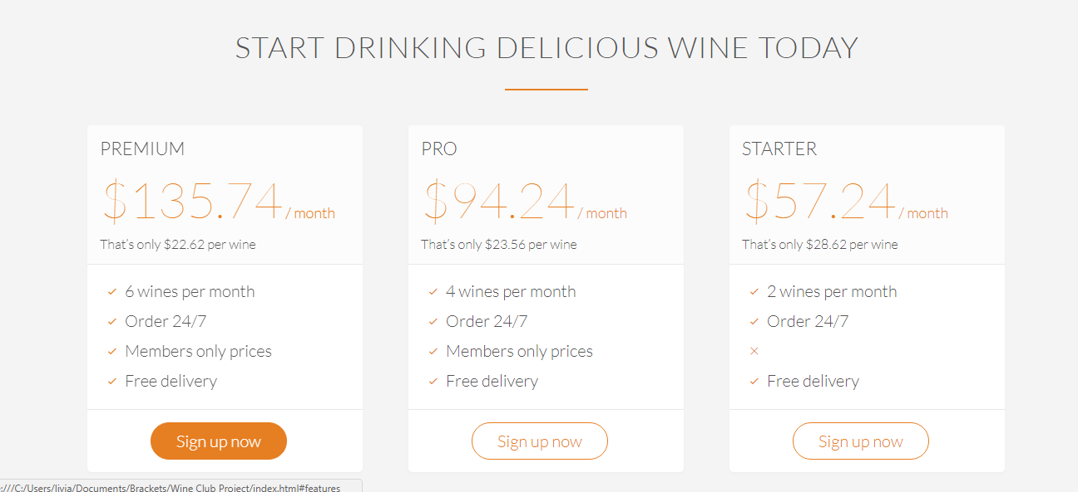

## Phase III Testing the program

The website was tested in three different browsers (Chrome, Firefox and Opera) to guarantee its stability and design. The responsivity of the website was also tested to ensure that it would maintain its good appearance in different sizes of screen (from mobile to large computer screens). Once the screen gets smaller, the website adapts to it and change the place of some icons, this was done using media queries.

# Conclusion

I’ve learned what it is and what are the usages of HTML, CSS, JavaScript and jQuery. In HTML, I learned how to structure a web site, by creating different containers, tables, adding images and more. In CSS, I learned how to apply style to a web site, like changing its background color, letter color and font, how to highlight the text and more. In JavaScript, I learned how to create functions, that can validate user input or perform on click actions. In jQuery, I learned how to include animations in a web site like how to override text, how to hide and show text and more.